**Experiment No. 9**

PART A

(PART A: TO BE REFFERED BY STUDENTS)

**A.1 Aim:**

Back End Development Phase 3

**A.2 Prerequisite:**

Core java programming and basic knowledge of database

**A.3 Outcome:**

**After successful completion of this experiment students will be able to**

1. Create Database of an application using SQLite or MySQL database

**A.4. Procedure:**

**Tasks:**

a) Create database of your application or backend functionality

b) Paste the code of database

c) Save the document as **EXP9_ your Roll no.**

PART B

(PART B: TO BE COMPLETED BY STUDENTS)

**(Students must submit the soft copy as per following segments within two hours of the practical. The soft copy must be uploaded on the Blackboard or emailed to the concerned lab in charge faculties at the end of the practical in case the there is no Black board access available)**

|  |  |
| --- | --- |
| Roll No.B046 | Name: Pranav Joshi |
| Program: B.tech Computer | Division: B |
| Semester: IV | Batch : B3 |
| Date of Experiment: 2-4-15 | Date of Submission: 9-4-15 |
| Grade : |  |

B.1 Task to be done:

**1)** Paste Source code of .xml and .java files in this section along with output.

private Button okBtn;

Handler handler = new Handler();

private static int count=0;

final Runnable r = new Runnable() {

public void run() {

switch (count) {

case 0:

okBtn.setBackgroundColor(getResources().getColor(R.color.red));

okBtn.setTag(0);

break;

case 1:

okBtn.setBackgroundColor(getResources().getColor(R.color.blue));

okBtn.setTag(1);

break;

case 2:

okBtn.setBackgroundColor(getResources().getColor(R.color.green));

okBtn.setTag(2);

break;

case 3:

okBtn.setBackgroundColor(getResources().getColor(R.color.white));

okBtn.setTag(3);

break;

default:

okBtn.setBackgroundColor(getResources().getColor(R.color.white));

okBtn.setTag(0);

break;

}

count++;

if(count!=5){

handler.postDelayed(this, 1000);

}

else{

startActivity(new Intent(Step_3_Activity.this, Drunk_Activity.class));

finish();

}

}

};

@Override

public void onCreate(Bundle savedInstanceState) {

super.onCreate(savedInstanceState);

setContentView(R.layout.step_3);

okBtn = (Button) findViewById(R.id.ok_button);

handler.postDelayed(r, 1000);

}

@Override

public void onClick(View v) {

if(((Integer)v.getTag())==3)

{

//Toast.makeText(Step_3_Activity.this, "Passed Screen test \n Next, MCQ test \n Coming soon !", Toast.LENGTH_LONG).show();

handler.removeCallbacks(r);

startActivity(new Intent(Step_3_Activity.this, Step_4_Activity.class));

finish();

}

else

{

startActivity(new Intent(Step_3_Activity.this, Drunk_Activity.class));

finish();

}

}

@Override

public void onBackPressed() {

// TODO Auto-generated method stub

}

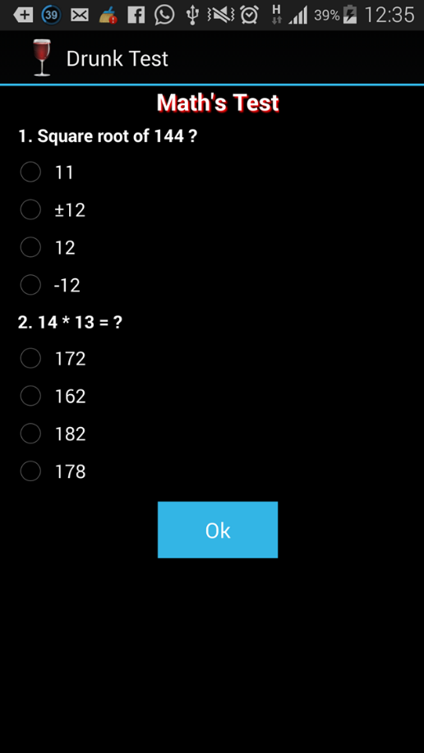

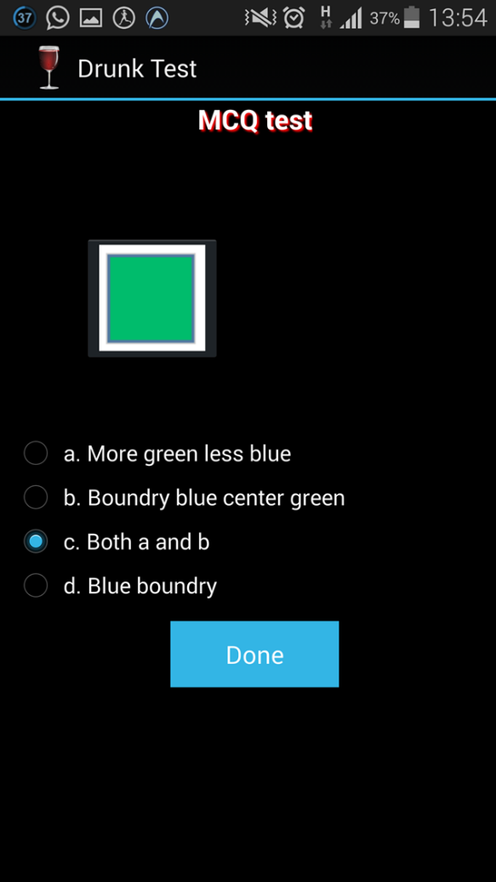

// Upgrading database

@Override

public void onUpgrade(SQLiteDatabase db, int oldVersion, int newVersion) {

// Drop older table if existed

db.execSQL("DROP TABLE IF EXISTS " + TABLE_COLORS);

// Create tables again

onCreate(db);

}

package com.drunktest;

import android.app.Application;

public class Bootstrap extends Application{

public static String [] questionsArray = new String[6];

public static String [][] answerOptionsArray = new String[6][4];

public static int queCount=0;

public static int [] answers = new int[6];

@Override

public void onCreate() {

// TODO Auto-generated method stub

super.onCreate();

questionsArray[0] = " Difference between no of matchsticks?";

questionsArray[1] = " How many triangles?";

questionsArray[2] = " How many differences?";

questionsArray[3] = " How many numbers can you see?";

questionsArray[4] = " Which line is longer?";

questionsArray[5] = " How many pairs of eyes and noses do you see?";

answers[0] = 4;

answers[1] = 3;

answers[2] = 2;

answers[3] = 2;

answers[4] = 3;

answers[5] = 2;

answerOptionsArray[0][0] = "a) 2";

answerOptionsArray[0][1] = "b) 1";

answerOptionsArray[0][2] = "c) -2";

answerOptionsArray[0][3] = "d) a & c";

answerOptionsArray[1][0] = "a) 24";

answerOptionsArray[1][1] = "b) 25";

answerOptionsArray[1][2] = "c) 26";

answerOptionsArray[1][3] = "d) 17";

answerOptionsArray[2][0] = "a) 13";

answerOptionsArray[2][1] = "b) 15";

answerOptionsArray[2][2] = "c) 12";

answerOptionsArray[2][3] = "d) 17";

answerOptionsArray[3][0] = "a) 3";

answerOptionsArray[3][1] = "b) 0";

answerOptionsArray[3][2] = "c) 4";

answerOptionsArray[3][3] = "d) 2";

answerOptionsArray[4][0] = "a) A";

answerOptionsArray[4][1] = "b) B";

answerOptionsArray[4][2] = "c) Both are equal";

answerOptionsArray[4][3] = "d) Wrong question";

answerOptionsArray[5][0] = "a) 1 & 2";

answerOptionsArray[5][1] = "b) 2 & 0";

answerOptionsArray[5][2] = "c) 4 & 2";

answerOptionsArray[5][3] = "d) Wrong question";

}

}

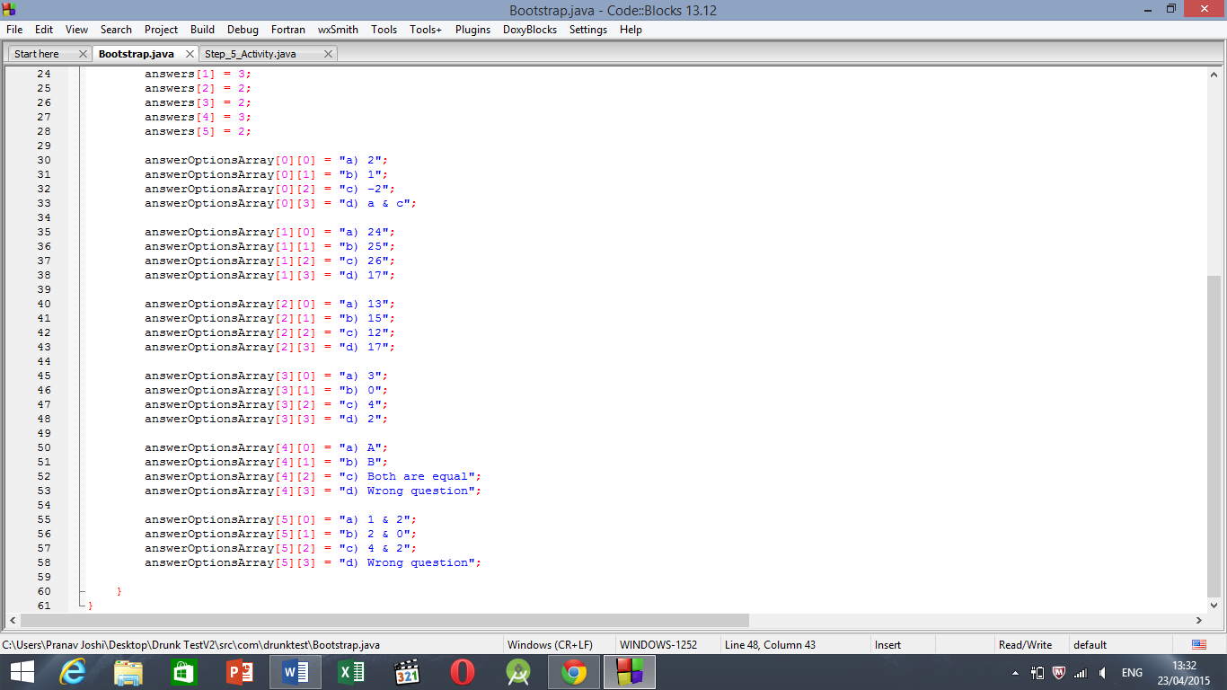

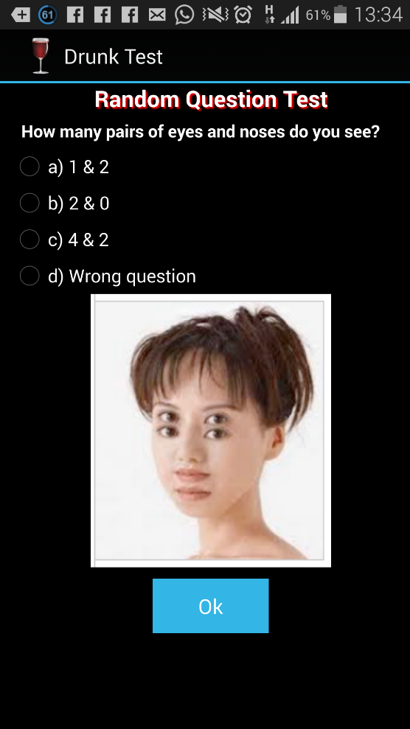

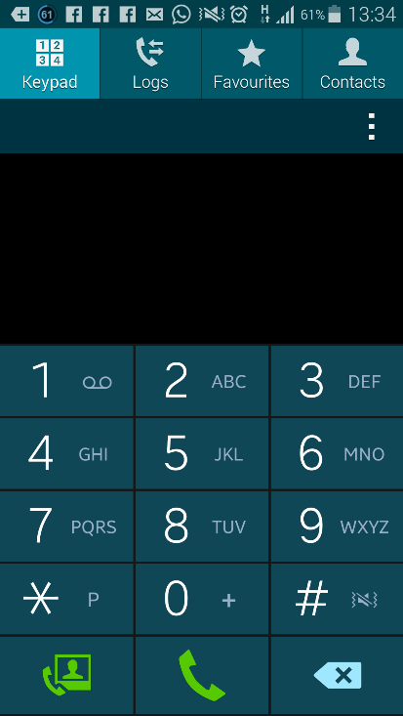

B.3 Conclusion:

Hence we have used bootstrap connectivity and resources which help us further in realizing our implementation of application idea and imparting dynamism to the application.